Salk PTO
Regular Meeting
November 17, 2015
Minutes

I. Call To Order
The meeting was called to order by Kristie Bielinski at 7:02 p.m. in the Media Center

Present: President Kristie Bielinski, Vice President Nikki Aquino, Secretary Cara Tonn, and Treasurer David Klink

Absent (Excused): Executive Board Assistant Sheri Vahovick

Recording Secretary: Cara Tonn

Public: Dr. Donna Anderson

II. Review of October meeting’s minutes and Treasurer’s Report

Minutes approved by Dr. Anderson seconded by Kristie Bielinski.
Treasurer's Report approved by Nikki Aquino and seconded by Dr. Anderson.

III. Staff Representative – Dr. Anderson
- Seahawk Walk
  - Still waiting on Fenech invoice.

- Conferences
  - Signup Genius.
- Its Learning

- PBIS Breakfast

- Staff Request
  - Lana Budde asked for funds to purchase two apps totaling $63.98.

V. Old Business
- Family Fun Nights
- Chili's
  - We made $130.

- Great Skate
  - November 18.

- El Charro
  - Waiting for a check.

- Spirit Wear

- Bagel Day
  - Will revisit budget at the end of the year to add the line item back in.

VI. New Business
- Scrip

- Staff Holiday Gift
  - Dr. Anderson will survey the staff and get back to us.

VIII. Adjournment
Kristie Bielinski adjourned the meeting at 7:46 p.m.

Respectfully submitted,
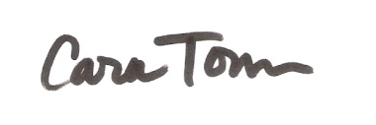

Cara Tonn

Next PTO Meeting: Tuesday, December 15 at 7:00 p.m.

